3.5 I can adjust settings so that others can access IT tools and devices for collaborative working

Another student in my class, Anna, came up with the idea of us collaborating on a work document [ <https://docs.google.com/document/d/1UCYIu4U2e8eK--2qGPUyiFjPHMBPfoDEJHRGPaA4EdU/edit>]

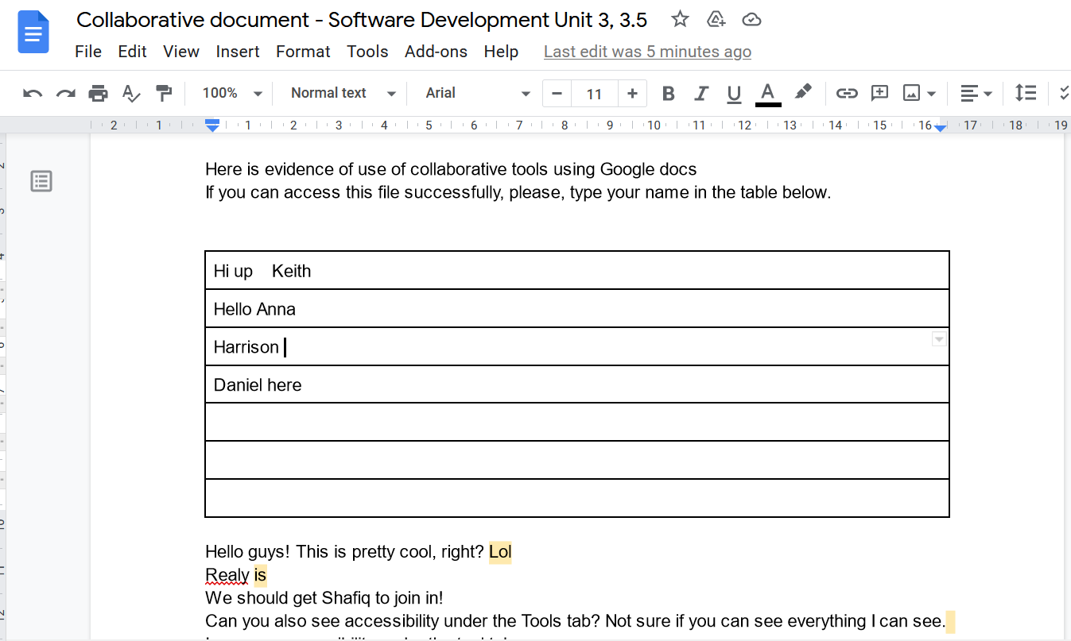

[The above photo shows a screenshot from the shared document]

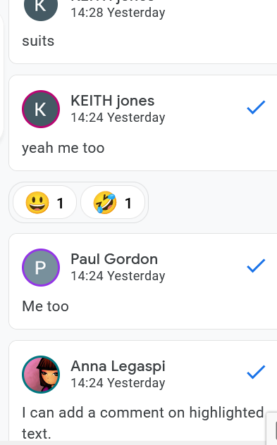

[The above photo shows comments on the document]

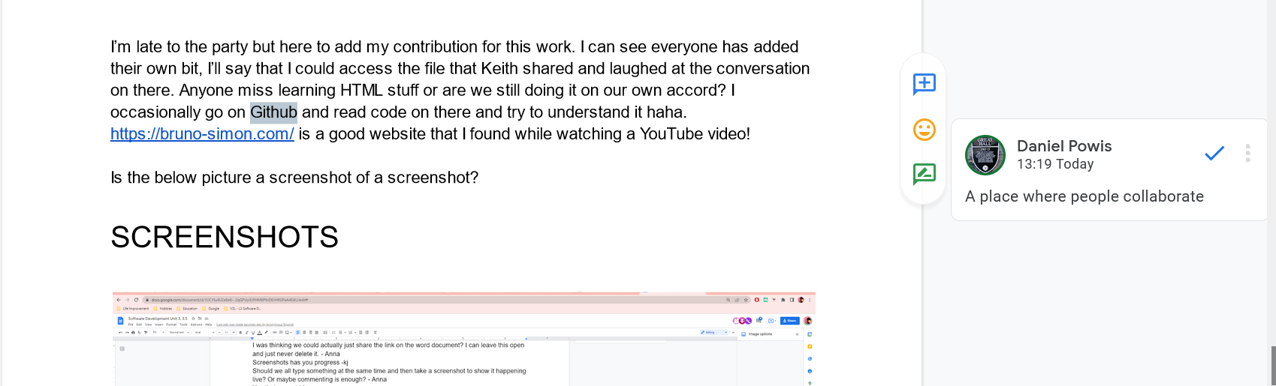

[The above photo shows a screenshot of the paragraphs and comment that I added on the document]